Lab - Configure CDP and LLDP
Topology
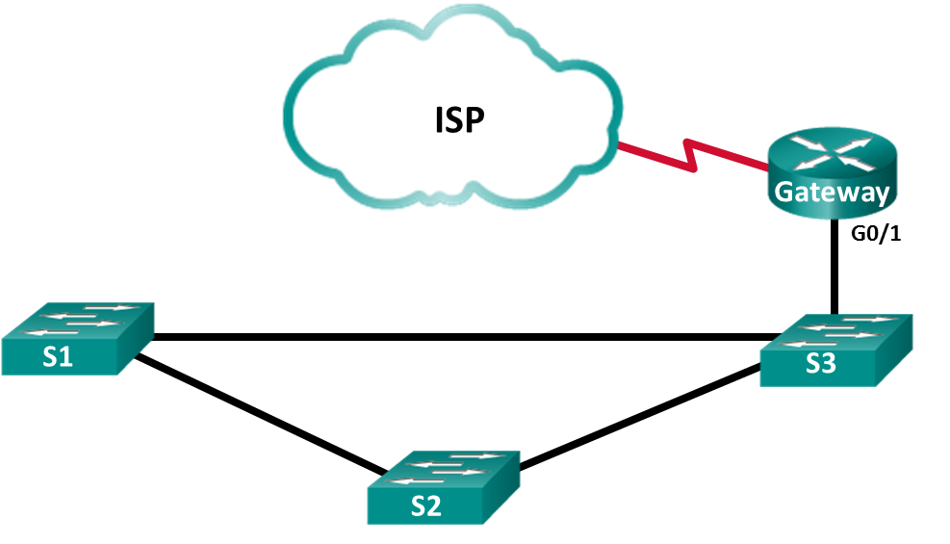
Addressing Table
Device | Interface | IP Address | Subnet Mask
Gateway | G0/1 | 192.168.1.254 | 255.255.255.0
Gateway | S0/0/1 | 209.165.200.226 | 255.255.255.252
ISP | S0/0/1 (DCE) | 209.165.200.225 | 255.255.255.252
Objectives
Part 1: Build the Network and Configure Basic Device Settings
Part 2: Network Discovery with CDP
Part 3: Network Discovery with LLDP
Background / Scenario
Cisco Discovery Protocol (CDP) is a Cisco proprietary protocol for network discovery on the data link layer. It can share information such as device names and IOS versions, with other physically connected Cisco devices. Link Layer Discovery Protocol (LLDP) is vendor-neutral protocol using on the data link layer for network discovery. It is mainly used with network devices in the local area network (LAN). The network devices advertise information, such as their identities and capabilities to their neighbors.
In this lab, you must document the ports that are connected to other switches using CDP and LLDP. You will document your findings in a network topology diagram. You will also enable or disable these discovery protocols as necessary.
Note: The routers used with CCNA hands-on labs are Cisco 1941 Integrated Services Routers (ISRs) with Cisco IOS Release 15.2(4)M3 (universalk9 image). The switches used are Cisco Catalyst 2960s with Cisco IOS Release 15.0(2) (lanbasek9 image). Other routers, switches, and Cisco IOS versions can be used. Depending on the model and Cisco IOS version, the commands available and the output produced might vary from what is shown in the labs. Refer to the Router Interface Summary Table at the end of this lab for the correct interface identifiers.
Note: Make sure that the routers and switches have been erased and have no startup configurations. If you are unsure, contact your instructor.
Required Resources
- 1 Router (Cisco 1941 with Cisco IOS Release 15.2(4)M3 universal image or comparable)
- 3 Switches (Cisco 2960 with Cisco IOS Release 15.0(2) lanbasek9 image or comparable)
- Console cables to configure the Cisco IOS devices via the console ports
- Ethernet cables as shown in the topology
- Build the Network and Configure Basic Device Settings
In Part 1, you will set up the network topology and configure basic settings on the router and switches.
  - Cable the network as shown in the topology.
The Ethernet ports used on the switches are not specified in the topology. You may choose to use any Ethernet ports to cable the switches as shown in the topology diagram.
  - Initialize and reload the network devices as necessary.
  - Configure basic device settings for the switches.
    - Console into the device and enable privileged EXEC mode.
    - Enter configuration mode.
    - Disable DNS lookup to prevent the switch from attempting to translate incorrectly entered commands as though they were host names.
    - Configure the hostname according to the topology.
    - Verify that the switchports with connected Ethernet cables are enabled.
    - Save the running configuration to the startup configuration file.
  - Configure basic device settings for the routers.
    - Console into the device and enable privileged EXEC mode.
    - Enter configuration mode.
    - Copy and paste the following configurations into the routers.
ISP:
hostname ISP
no ip domain lookup
interface Serial0/0/1
ip address 209.165.200.225 255.255.255.252
no shutdown
Gateway:
hostname Gateway
no ip domain lookup
interface GigabitEthernet0/1
ip address 192.168.1.254 255.255.255.0
ip nat inside
no shutdown
interface Serial0/0/1
ip address 209.165.200.226 255.255.255.252
ip nat outside
no shutdown
ip nat inside source list 1 interface Serial0/0/1 overload
access-list 1 permit 192.168.1.0 0.0.0.255
    - Save the running configuration to the startup configuration file.
- Network Discovery with CDP
On Cisco devices, CDP is enabled by default. You will use CDP to discover the ports that are currently connected.
    - On router Gateway, enter the show cdp command in the privileged EXEC mode to verify that CDP is currently enabled on router Gateway.
Gateway# show cdp
Global CDP information:
Sending CDP packets every 60 seconds
Sending a holdtime value of 180 seconds
Sending CDPv2 advertisements is enabled
How often are CDP packets sent?
____________________________________________________________________________________
If CDP is disabled on Gateway, enable CDP by issuing the cdp run command in the global configuration mode.
Gateway(config)# cdp run
Gateway(config)# end
    - Issue the show cdp interface to list the interfaces that are participating in CDP advertisements.
Gateway# show cdp interface
Embedded-Service-Engine0/0 is administratively down, line protocol is down
Encapsulation ARPA
Sending CDP packets every 60 seconds
Holdtime is 180 seconds
GigabitEthernet0/0 is administratively down, line protocol is down
Encapsulation ARPA
Sending CDP packets every 60 seconds
Holdtime is 180 seconds
GigabitEthernet0/1 is up, line protocol is up
Encapsulation ARPA
Sending CDP packets every 60 seconds
Holdtime is 180 seconds
Serial0/0/0 is administratively down, line protocol is down
Encapsulation HDLC
Sending CDP packets every 60 seconds
Holdtime is 180 seconds
Serial0/0/1 is up, line protocol is up
Encapsulation HDLC
Sending CDP packets every 60 seconds
Holdtime is 180 seconds

cdp enabled interfaces : 5
interfaces up : 2
interfaces down : 3
How many interfaces are participating in the CDP advertisement? Which interfaces are up?
____________________________________________________________________________________
    - Issue the show cdp neighbors command to determine the CDP neighbors.
Gateway# show cdp neighbors
Capability Codes: R - Router, T - Trans Bridge, B - Source Route Bridge
S - Switch, H - Host, I - IGMP, r - Repeater, P - Phone,
D - Remote, C - CVTA, M - Two-port Mac Relay

Device ID Local Intrfce Holdtme Capability Platform Port ID
ISP Ser 0/0/1 158 R B S I CISCO1941 Ser 0/0/1
S3 Gig 0/1 170 S I WS-C2960- Fas 0/5
    - For more details on CDP neighbors, issue the show cdp neighbors detail command.
Gateway# show cdp neighbors detail
-------------------------
Device ID: ISP
Entry address(es):
IP address: 209.165.200.225
Platform: Cisco CISCO1941/K9, Capabilities: Router Source-Route-Bridge Switch IGMP
Interface: Serial0/0/1, Port ID (outgoing port): Serial0/0/1
Holdtime : 143 sec

Version :
Cisco IOS Software, C1900 Software (C1900-UNIVERSALK9-M), Version 15.4(3)M2, RELEASE SOFTWARE (fc2)
Technical Support: http://www.cisco.com/techsupport
Copyright (c) 1986-2015 by Cisco Systems, Inc.
Compiled Fri 06-Feb-15 17:01 by prod_rel_team

advertisement version: 2
Management address(es):
IP address: 209.165.200.225

-------------------------
Device ID: S3
Entry address(es):
Platform: cisco WS-C2960-24TT-L, Capabilities: Switch IGMP
Interface: GigabitEthernet0/1, Port ID (outgoing port): FastEthernet0/5
Holdtime : 158 sec

Version :
Cisco IOS Software, C2960 Software (C2960-LANBASEK9-M), Version 15.0(2)SE7, RELEASE SOFTWARE (fc1)
Technical Support: http://www.cisco.com/techsupport
Copyright (c) 1986-2014 by Cisco Systems, Inc.
Compiled Thu 23-Oct-14 14:49 by prod_rel_team

advertisement version: 2
Protocol Hello: OUI=0x00000C, Protocol ID=0x0112; payload len=27, value=00000000FFFFFFFF010221FF0000000000000CD996E87400FF0000
VTP Management Domain: ''
Native VLAN: 1
Duplex: full
    - What can you learn about ISP and S3 from the outputs of the show cdp neighbors detail command?
____________________________________________________________________________________
____________________________________________________________________________________
    - Configure the SVI on S3. Use an available IP address in 192.168.1.0 / 24 network. Configure 192.168.1.254 as the default gateway.
S3(config)# interface vlan 1
S3(config-if)# ip address 192.168.1.3 255.255.255.0
S3(config-if)# no shutdown
S3(config-if)# exit
S3(config)# ip default-gateway 192.168.1.254
    - Issue the show cdp neighbors detail command on Gateway. What additional information is available?
____________________________________________________________________________________
    - For security reasons, it is a good idea to turn off CDP on an interface facing an external network. Issue the no cdp enable in the interface configuration mode on the S0/0/1 interface on Gateway.
Gateway(config)# interface s0/0/1
Gateway(config-if)# no cdp enable
Gateway(config-if)# end
To verify that CDP has been turned off on the interface S0/0/1, issue the show cdp neighbors or show cdp interface command. You may need to wait for the hold time to expire. The hold time is the amount of time the network devices will hold the CDP packets until the devices discard them.
Gateway# show cdp neighbors
Capability Codes: R - Router, T - Trans Bridge, B - Source Route Bridge
S - Switch, H - Host, I - IGMP, r - Repeater, P - Phone,
D - Remote, C - CVTA, M - Two-port Mac Relay

Device ID Local Intrfce Holdtme Capability Platform Port ID
S3 Gig 0/1 161 S I WS-C2960- Fas 0/5
The interface S0/0/1 on Gateway no longer has a CDP adjacency with the ISP router. But it still has CDP adjacencies with other interfaces.
Gateway# show cdp interface
Embedded-Service-Engine0/0 is administratively down, line protocol is down
Encapsulation ARPA
Sending CDP packets every 60 seconds
Holdtime is 180 seconds
GigabitEthernet0/0 is administratively down, line protocol is down
Encapsulation ARPA
Sending CDP packets every 60 seconds
Holdtime is 180 seconds
GigabitEthernet0/1 is up, line protocol is up
Encapsulation ARPA
Sending CDP packets every 60 seconds
Holdtime is 180 seconds
Serial0/0/0 is administratively down, line protocol is down
Encapsulation HDLC
Sending CDP packets every 60 seconds
Holdtime is 180 seconds

cdp enabled interfaces : 4
interfaces up : 1
interfaces down : 3
    - To disable CDP globally, issue the no cdp run command in the global configuration mode.
Gateway# conf t
Gateway(config)# no cdp run
Gateway(config)# end
Which command(s) would you use to verify that CDP has been disabled?
____________________________________________________________________________________
    - Enable CDP globally on Gateway. How many interfaces are CDP enabled? Which interfaces are CDP disabled?
____________________________________________________________________________________
    - Console into all the switches and use the CDP commands to determine the Ethernet ports that connected to other devices. An example of the CDP commands for S3 is displayed below.
S3# show cdp neighbors
Capability Codes: R - Router, T - Trans Bridge, B - Source Route Bridge
S - Switch, H - Host, I - IGMP, r - Repeater, P - Phone,
D - Remote, C - CVTA, M - Two-port Mac Relay

Device ID Local Intrfce Holdtme Capability Platform Port ID
Gateway Fas 0/5 143 R B S I CISCO1941 Gig 0/1
S2 Fas 0/2 173 S I WS-C2960- Fas 0/4
S1 Fas 0/4 171 S I WS-C2960- Fas 0/4
- Network Discovery with LLDP
On Cisco devices, LLDP maybe enabled by default. You will use LLDP to discover the ports that are currently connected.
    - On Gateway, enter the show lldp command in the privileged EXEC mode.
Gateway# show lldp
% LLDP is not enabled
If LLDP is disabled, enter the lldp run command in the global configuration mode.
Gateway(config)# lldp run
    - Use the show lldp command to verify that LLDP is enabled on Gateway.
Gateway# show lldp

Global LLDP Information:
Status: ACTIVE
LLDP advertisements are sent every 30 seconds
LLDP hold time advertised is 120 seconds
LLDP interface reinitialisation delay is 2 seconds
Issue the show lldp neighbors command. Which devices are neighbors to Gateway?
____________________________________________________________________________________
    - If there are no LLDP neighbors for Gateway, enable LLDP on the switches and ISP. Issue lldp run in the global configuration mode on the devices.
S1(config)# lldp run
S2(config)# lldp run
S3(config)# lldp run
ISP(config)# lldp run
    - Issue the show lldp neighbors command on the switches and router to list the LLDP enabled ports. The output for Gateway is shown below.
Gateway# show lldp neighbors
Capability codes:
(R) Router, (B) Bridge, (T) Telephone, (C) DOCSIS Cable Device
(W) WLAN Access Point, (P) Repeater, (S) Station, (O) Other

Device ID Local Intf Hold-time Capability Port ID
S3 Gi0/1 120 B Fa0/5

Total entries displayed: 1
    - Issue the show lldp neighbors detail command on Gateway.
Gateway# show lldp neighbors detail
------------------------------------------------
Local Intf: Gi0/1
Chassis id: 0cd9.96e8.7400
Port id: Fa0/5
Port Description: FastEthernet0/5
System Name: S3

System Description:
Cisco IOS Software, C2960 Software (C2960-LANBASEK9-M), Version 15.0(2)SE7, RELEASE SOFTWARE (fc1)
Technical Support: http://www.cisco.com/techsupport
Copyright (c) 1986-2014 by Cisco Systems, Inc.
Compiled Thu 23-Oct-14 14:49 by prod_rel_team

Time remaining: 103 seconds
System Capabilities: B
Enabled Capabilities: B
Management Addresses:
IP: 192.168.1.3
Auto Negotiation - supported, enabled
Physical media capabilities:
100base-TX(FD)
100base-TX(HD)
10base-T(FD)
10base-T(HD)
Media Attachment Unit type: 16
Vlan ID: 1

Total entries displayed: 1

What port is used on S3 to connect to the Gateway router?
____________________________________________________________________________________
    - Use the show command outputs from CDP and LLDP to document the connected ports in the network topology.
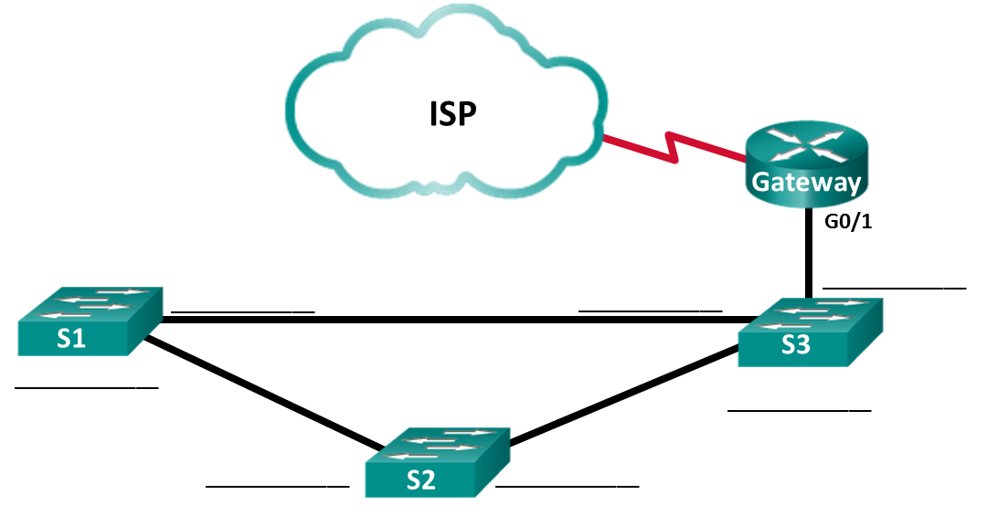
Reflection
Within a network, on which interfaces should you not use discovery protocols? Explain.
_______________________________________________________________________________________
_______________________________________________________________________________________
_______________________________________________________________________________________
_______________________________________________________________________________________
Router Interface Summary Table
Router Interface Summary
Router Model | Ethernet Interface #1 | Ethernet Interface #2 | Serial Interface #1 | Serial Interface #2
1800 | Fast Ethernet 0/0 (F0/0) | Fast Ethernet 0/1 (F0/1) | Serial 0/0/0 (S0/0/0) | Serial 0/0/1 (S0/0/1)
1900 | Gigabit Ethernet 0/0 (G0/0) | Gigabit Ethernet 0/1 (G0/1) | Serial 0/0/0 (S0/0/0) | Serial 0/0/1 (S0/0/1)
2801 | Fast Ethernet 0/0 (F0/0) | Fast Ethernet 0/1 (F0/1) | Serial 0/1/0 (S0/1/0) | Serial 0/1/1 (S0/1/1)
2811 | Fast Ethernet 0/0 (F0/0) | Fast Ethernet 0/1 (F0/1) | Serial 0/0/0 (S0/0/0) | Serial 0/0/1 (S0/0/1)
2900 | Gigabit Ethernet 0/0 (G0/0) | Gigabit Ethernet 0/1 (G0/1) | Serial 0/0/0 (S0/0/0) | Serial 0/0/1 (S0/0/1)
Note: To find out how the router is configured, look at the interfaces to identify the type of router and how many interfaces the router has. There is no way to effectively list all the combinations of configurations for each router class. This table includes identifiers for the possible combinations of Ethernet and Serial interfaces in the device. The table does not include any other type of interface, even though a specific router may contain one. An example of this might be an ISDN BRI interface. The string in parenthesis is the legal abbreviation that can be used in Cisco IOS commands to represent the interface.
Device Configs - Final
Router ISP
ISP# show run
Building configuration...

Current configuration : 1285 bytes
!
version 15.4
service timestamps debug datetime msec
service timestamps log datetime msec
no service password-encryption
!
hostname ISP
!
boot-start-marker
boot-end-marker
!
no aaa new-model
memory-size iomem 15
!
ip cef
no ipv6 cef
!
multilink bundle-name authenticated
!
cts logging verbose
!
redundancy
!
lldp run
!
interface Embedded-Service-Engine0/0
no ip address
shutdown
!
interface GigabitEthernet0/0
no ip address
shutdown
duplex auto
speed auto
!
interface GigabitEthernet0/1
no ip address
shutdown
duplex auto
speed auto
!
interface Serial0/0/0
no ip address
shutdown
!
interface Serial0/0/1
ip address 209.165.200.225 255.255.255.252
clock rate 125000
!
ip forward-protocol nd
!
no ip http server
no ip http secure-server
!
control-plane
!
line con 0
line aux 0
line 2
no activation-character
no exec
transport preferred none
transport output pad telnet rlogin lapb-ta mop udptn v120 ssh
stopbits 1
line vty 0 4
login
transport input none
!
scheduler allocate 20000 1000
!
end
Router Gateway
Gateway# show run
Building configuration...

Current configuration : 1524 bytes
!
version 15.4
service timestamps debug datetime msec
service timestamps log datetime msec
no service password-encryption
!
hostname Gateway
!
boot-start-marker
boot-end-marker
!
no aaa new-model
memory-size iomem 15
!
no ip domain lookup
ip cef
no ipv6 cef
!
multilink bundle-name authenticated
!
cts logging verbose
!
redundancy
!
lldp run
!
interface Embedded-Service-Engine0/0
no ip address
shutdown
!
interface GigabitEthernet0/0
no ip address
shutdown
duplex auto
speed auto
!
interface GigabitEthernet0/1
ip address 192.168.1.254 255.255.255.0
ip nat inside
ip virtual-reassembly in
duplex auto
speed auto
!
interface Serial0/0/0
no ip address
shutdown
clock rate 125000
!
interface Serial0/0/1
ip address 209.165.200.226 255.255.255.252
ip nat outside
ip virtual-reassembly in
no cdp enable
!
ip forward-protocol nd
!
no ip http server
no ip http secure-server
!
ip nat inside source list 1 interface Serial0/0/1 overload
!
access-list 1 permit 192.168.1.0 0.0.0.255
!
control-plane
!
line con 0
line aux 0
line 2
no activation-character
no exec
transport preferred none
transport output pad telnet rlogin lapb-ta mop udptn v120 ssh
stopbits 1
line vty 0 4
login
transport input none
!
scheduler allocate 20000 1000
!
end
Switch S1
S1# show run
Building configuration...

Current configuration : 1308 bytes
!
version 15.0
no service pad
service timestamps debug datetime msec
service timestamps log datetime msec
no service password-encryption
!
hostname S1
!
boot-start-marker
boot-end-marker
!
no aaa new-model
system mtu routing 1500
!
spanning-tree mode pvst
spanning-tree extend system-id
!
vlan internal allocation policy ascending
lldp run
!
interface FastEthernet0/1
!
interface FastEthernet0/2
!
interface FastEthernet0/3
!
interface FastEthernet0/4
!
interface FastEthernet0/5
!
interface FastEthernet0/6
!
interface FastEthernet0/7
!
interface FastEthernet0/8
!
interface FastEthernet0/9
!
interface FastEthernet0/10
!
interface FastEthernet0/11
!
interface FastEthernet0/12
!
interface FastEthernet0/13
!
interface FastEthernet0/14
!
interface FastEthernet0/15
!
interface FastEthernet0/16
!
interface FastEthernet0/17
!
interface FastEthernet0/18
!
interface FastEthernet0/19
!
interface FastEthernet0/20
!
interface FastEthernet0/21
!
interface FastEthernet0/22
!
interface FastEthernet0/23
!
interface FastEthernet0/24
!
interface GigabitEthernet0/1
!
interface GigabitEthernet0/2
!
interface Vlan1
no ip address
!
ip http server
ip http secure-server
!
line con 0
line vty 5 15
!
end
Switch S2
S2# show run
Building configuration...

Current configuration : 1308 bytes
!
version 15.0
no service pad
service timestamps debug datetime msec
service timestamps log datetime msec
no service password-encryption
!
hostname S2
!
boot-start-marker
boot-end-marker
!
no aaa new-model
system mtu routing 1500
!
spanning-tree mode pvst
spanning-tree extend system-id
!
vlan internal allocation policy ascending
lldp run
!
interface FastEthernet0/1
!
interface FastEthernet0/2
!
interface FastEthernet0/3
!
interface FastEthernet0/4
!
interface FastEthernet0/5
!
interface FastEthernet0/6
!
interface FastEthernet0/7
!
interface FastEthernet0/8
!
interface FastEthernet0/9
!
interface FastEthernet0/10
!
interface FastEthernet0/11
!
interface FastEthernet0/12
!
interface FastEthernet0/13
!
interface FastEthernet0/14
!
interface FastEthernet0/15
!
interface FastEthernet0/16
!
interface FastEthernet0/17
!
interface FastEthernet0/18
!
interface FastEthernet0/19
!
interface FastEthernet0/20
!
interface FastEthernet0/21
!
interface FastEthernet0/22
!
interface FastEthernet0/23
!
interface FastEthernet0/24
!
interface GigabitEthernet0/1
!
interface GigabitEthernet0/2
!
interface Vlan1
no ip address
!
ip http server
ip http secure-server
!
line con 0
line vty 5 15
!
end
Switch S3
S3# show run
Building configuration...

Current configuration : 1364 bytes
!
version 15.0
no service pad
service timestamps debug datetime msec
service timestamps log datetime msec
no service password-encryption
!
hostname S3
!
boot-start-marker
boot-end-marker
!
no aaa new-model
system mtu routing 1500
!
spanning-tree mode pvst
spanning-tree extend system-id
!
vlan internal allocation policy ascending
lldp run
!
interface FastEthernet0/1
!
interface FastEthernet0/2
!
interface FastEthernet0/3
!
interface FastEthernet0/4
!
interface FastEthernet0/5
!
interface FastEthernet0/6
!
interface FastEthernet0/7
!
interface FastEthernet0/8
!
interface FastEthernet0/9
!
interface FastEthernet0/10
!
interface FastEthernet0/11
!
interface FastEthernet0/12
!
interface FastEthernet0/13
!
interface FastEthernet0/14
!
interface FastEthernet0/15
!
interface FastEthernet0/16
!
interface FastEthernet0/17
!
interface FastEthernet0/18
!
interface FastEthernet0/19
!
interface FastEthernet0/20
!
interface FastEthernet0/21
!
interface FastEthernet0/22
!
interface FastEthernet0/23
!
interface FastEthernet0/24
!
interface GigabitEthernet0/1
!
interface GigabitEthernet0/2
!
interface Vlan1
no ip address
!
ip http server
ip http secure-server
!
line con 0
line vty 5 15
!
end

